**Assignment #5 - Creating a simple game using JavaScript**

**Course:** Client-Side Web Development - COMP 125

**Due Date:** July 26, 2019, 11:59pm

Implement a simple Bug Smasher browser-based (HTML5 canvas) game similar to the snapshot below:

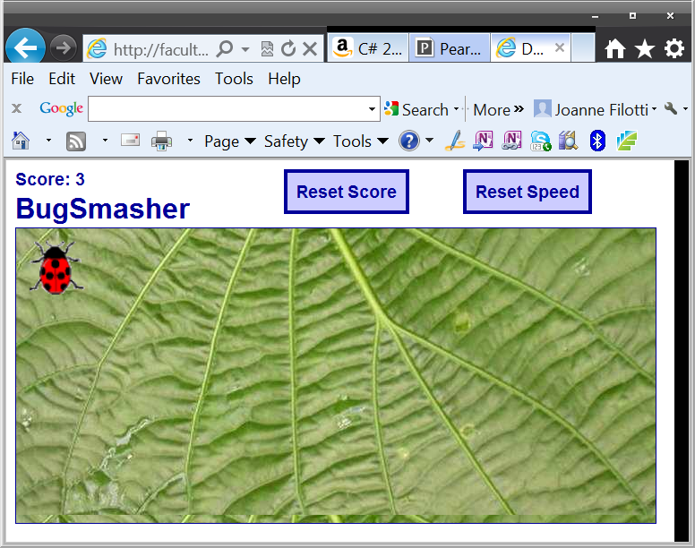

**Features:**

The bug hops randomly around the game area at a given interval. The player tries to catch the bug by clicking on it. If he succeeds, the score is incremented and the hopping interval is decremented by a number of milliseconds, so it gets harder to catch the bug.

If the game becomes too challenging, the player can reset the speed to the initial hopping interval by clicking the Reset Speed button.

If the player wants, he can start again by resetting the score by clicking the Reset Score button.

**Guidelines:**

Your GUI does not need to be laid out exactly as the above screenshot, you can use graphics of your own and a different page layout as long as the core functionality of the game is preserved.

Use as guidelines the game described at:

[**http://www.lostdecadegames.com/how-to-make-a-simple-html5-canvas-game/**](http://www.lostdecadegames.com/how-to-make-a-simple-html5-canvas-game/)